**COS30043: Interface Design and Development**

**Distinct Task 6.2: Custom Web Application**

**Student Name: Tran Quoc Dung**

**Student ID: 103803891**

**Problem Description**

Do you cherish cooking and need to investigate new recipes from various foods, diets, events, and expertise levels? On this condition, you ought to look at our site, which is a stage for trading cooking recipes on the web. Whether you are a beginner or a master chef, you can track down various recipes that suit your taste and preference. You can peruse our classes of recipes, includes Appetizer, Main Course and Dessert. You can likewise utilize our search function to track down recipes by keywords, and food-type. Our website also offers features such as ratings, reviews, comments, and more for users to interact with each other and share their feedback. More and more advancements are coming up straightaway. Our site is intended to give a helpful and pleasant experience for clients who love cooking and need to find new recipes.

**Solution Design**

**Website Functionalities**

**Home Page**

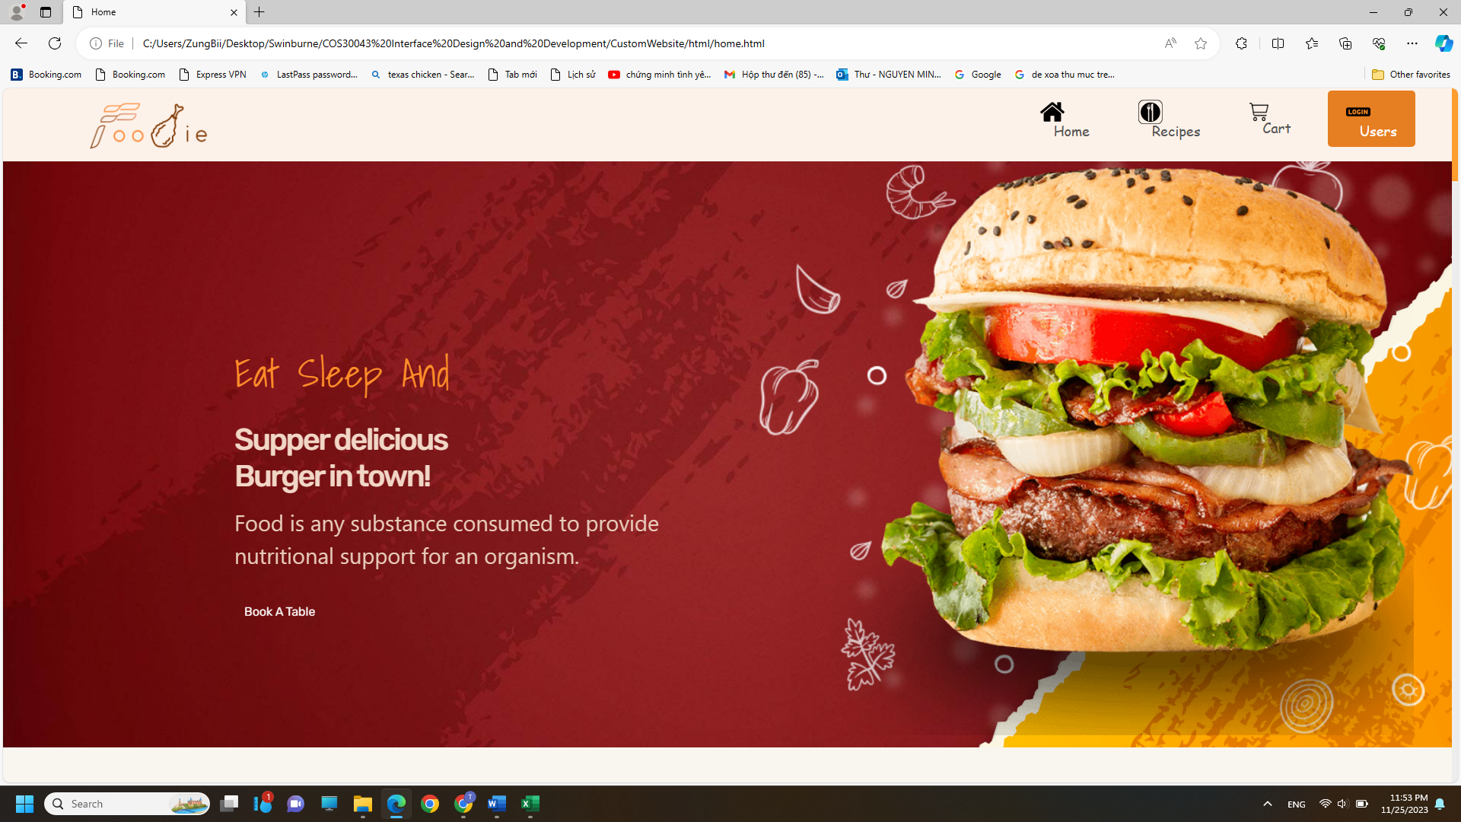

Homepage of Foodie Website introducing about foods and recipes

**Product Page**

Product Pages contains recipes for sale

Buying leads to Cart page.

**Cart Page**

**Login Page**

